DEVELOPMENT OF TRANSPARENT CROWDFUNDING DECENTRALISED APPLICATION FOR MEDICAL BILLS WITH FRAUD PREVENTION

BY

ABEL GODWIN
FT22BCMP0586

BSC. COMPUTER SCIENCE

JUNE, 2026

DECLARATION
I hereby declare that this project DEVELOPMENT OF TRANSPARENT CROWDFUNDING DECENTRALISED APPLICATION FOR MEDICAL BILLS WITH FRAUD PREVENTION, has been written by me and it is a report of my research work. It has not been presented in any previous application for the BSc. Computer Science. All quotations are indicated and sources of information specifically acknowledged by means of references.

------------------------ -------------------
ABEL GODWIN Date
FT22BCMP0586

CERTIFICATION
This project DEVELOPMENT OF TRANSPARENT CROWDFUNDING DECENTRALISED APPLICATION FOR MEDICAL BILLS WITH FRAUD PREVENTION meets the regulations governing the award of Bachelor of Science (BSc.), Nasarawa State University, Keffi, and is approved for its contribution to knowledge.

_________________________ ________________
Prof. Morufu Olalere Date
Supervisor

_________________________ ________________
Dr Binyamin A. Ajayi Date
HOD, Computer Science

_________________________ ________________
External Examiner Date

DEDICATION
This work is dedicated to God almighty, whose grace, wisdom, and strength have been my anchor throughout this academic journey.

ACKNOWLEDGEMENTS

First and foremost, I express my profound gratitude to the Almighty God for granting me the
Strength, wisdom, and perseverance throughout the course of this academic journey. I am
deeply grateful to my supervisor, Prof. Morufu Olalere whose unwavering support,
insightful guidance, and critical feedback were instrumental in shaping the direction and quality
of this project. His intellectual leadership and patience have significantly contributed to the
successful completion of this thesis. I also extend my heartfelt appreciation to all the lecturers
and staff members of the Department of Computer Science, Nasarawa State University,
Keffi, for their dedication, encouragement, and the conducive learning environment they have
consistently provided. My sincere thanks go to my course mates and colleagues whose
cooperation and camaraderie made this academic experience memorable and enriching.

ABSTRACT
This study is focused on the design and development of a transparent crowdfunding decentralized application (DApp) for medical bills with integrated fraud prevention mechanisms. The study addresses the persistent challenges of fraudulent fundraising campaigns, lack of transparency in fund management, weak donor trust, and the misuse of donated funds that characterize many existing medical crowdfunding platforms. A system development research design is adopted, involving the analysis, design, implementation, and testing of a blockchain-based crowdfunding platform that utilizes smart contracts, decentralized storage, and user verification to ensure transparency, accountability, and secure transactions. The proposed system is expected to enhance donor confidence by providing immutable transaction records, automated fund disbursement based on predefined conditions, and effective fraud prevention measures that verify the authenticity of fundraising campaigns. It is therefore concluded that the integration of blockchain technology and fraud prevention techniques into medical crowdfunding can significantly improve transparency, reduce fraudulent activities, promote accountability, and provide a more trustworthy and efficient platform for raising medical funds.

TABLE OF CONTENTS
DECLARATION ii
CERTIFICATION iii
DEDICATION iv
ACKNOWLEDGEMENTS v
ABSTRACT vi
LIST OF TABLES viii
LIST OF FIGURES ix
CHAPTER ONE 1
INTRODUCTION 1
1.1 Background to the Study 1
1.2 Statement of the Problem 3
1.3 Objectives of the Study 5
1.4 Significance of the Study 5
1.5 Scope of the Study 6
CHAPTER TWO 8
LITERATURE REVIEW 8
2.1 Conceptual Framework 8
2.2 Empirical Review 9
2.2.1 The Problems or Issues 10
2.2.2 Solutions Explored Previously 11
2.2.3 Gaps in Previous Solutions 14
CHAPTER THREE 16
RESEARCH METHODOLOGY 16
3.1 Research Design 16
3.2 System Design 17
3.2.1. System Architecture 18
3.2.2. Proposed System Framework 18
3.2.3 Algorithm 20
3.2.3 System Flowchart 22
3.2.4 Current System 24
3.2.5 Challenges in the Current System 24
3.2.3 Proposed System 25
3.3 Methods of Data Collection 29
3.3.1 Justification of Methods 30
REFERENCES 32

LIST OF TABLES
Table 2.1 Summary of Reviewed Literature…………………………………10-11

LIST OF FIGURES
Figure 3.2:. System Flowchart……………………………………………………………...22
Figure 3.1: Three-Layer System Architecture of the Proposed DApp……………………..25
Figure 3.2: Use Case Diagram of the Proposed DApp………………………………………………………26

CHAPTER ONE

INTRODUCTION

1.1 Background to the Study
The rapid expansion of digital financial ecosystems has transformed how individuals and organisations seek and provide support for critical human needs, including healthcare financing. Medical crowdfunding, a practice wherein individuals solicit small financial contributions from a large pool of donors through online platforms, has emerged as a vital lifeline for patients confronted with catastrophic medical bills in both developed and developing economies. The aim of this research is to design and implement a transparent crowdfunding decentralised application (DApp) for medical bills that integrates robust fraud prevention mechanisms, thereby addressing the dual crisis of healthcare inaccessibility and donor mistrust that plagues existing platforms.
Medical crowdfunding has grown significantly over the past decade; platforms such as GoFundMe, MedGift, and GiveForward have collectively facilitated the transfer of billions of dollars toward healthcare-related campaigns. Despite this growth, these platforms operate predominantly as centralised intermediaries, meaning that donors must place unconditional trust in both the platform operator and the campaign creator to ensure that funds are appropriately collected and disbursed. This trust-based model has proven fragile, as it creates fertile conditions for fraudulent activities, including the fabrication of medical conditions, misrepresentation of financial need, and misappropriation of donated funds. The phenomenon of interest in this study, therefore, is the persistent vulnerability of medical crowdfunding systems to fraud, and the inadequate transparency mechanisms that currently characterise such platforms.
The people most directly affected by this problem are multiple stakeholders: genuine patients who are denied funding because donor confidence has been eroded by high-profile fraud cases, philanthropic donors who suffer financial and emotional harm when their contributions are misused, and medical practitioners who increasingly find their institutions implicated in unverifiable campaign documentation. The environment in which this issue unfolds spans primary and secondary healthcare settings, where patients are confronted with bills that exceed personal financial capacity and are therefore driven toward public fundraising. The proliferation of mobile internet access across sub-Saharan Africa, Asia, and Latin America has further expanded this environment, bringing millions of new but financially vulnerable users into the crowdfunding space without the institutional protections that govern formal financial services.
Previous attempts to resolve the challenge of fraud in crowdfunding have taken several directions. Platform-level measures such as identity verification, campaign moderation, and post-disbursement reporting requirements have been introduced by major operators; however, these controls are administered by the same centralised entities whose interests may not always align with those of donors or beneficiaries. Academic research has proposed machine learning-based fraud detection models that analyse campaign text, donor behaviour, and social network signals to flag suspicious activity, and some of these approaches have demonstrated promising classification accuracy. More recently, blockchain technology has been explored as a foundational infrastructure for transparent fund management; pilot applications in charitable giving and microfinance have shown that smart contracts can automate disbursement conditions and provide an immutable audit trail. Nevertheless, none of these isolated approaches has been successfully integrated into a coherent, production-ready system that simultaneously addresses campaign authentication, real-time fraud detection, and transparent fund disbursement within the specific context of medical crowdfunding.
This research addresses that gap by developing a Transparent Crowdfunding DApp for Medical Bills with Fraud Prevention. The system leverages Ethereum-compatible smart contracts to govern the creation, funding, and disbursement lifecycle of each campaign, ensuring that all transactions are recorded on a public ledger and that funds are released only when pre-specified conditions are met. Embedded within the application is a fraud detection layer trained on features derived from campaign metadata, documentation authenticity signals, and donor contribution patterns. Together, these components constitute a trustless, verifiable crowdfunding environment in which neither the platform nor any single actor can unilaterally divert funds. The specific objectives pursued to realise this aim are detailed in Section 1.3.

1.2 Statement of the Problem
Medical debt constitutes one of the leading causes of personal bankruptcy and financial catastrophe globally. According to the World Health Organization (2023), approximately 2 billion people face catastrophic or impoverishing health expenditures each year, with a significant proportion resorting to informal and digital fundraising mechanisms to cover costs. Crowdfunding platforms have positioned themselves as accessible, community-driven alternatives to formal insurance and government support; however, they suffer from an acute fraud problem. Studies have estimated that between 15 and 37 percent of medical crowdfunding campaigns contain materially misleading information, ranging from exaggerated diagnoses to entirely fabricated medical emergencies (Snyder et al., 2020). This erosion of campaign integrity not only causes direct financial harm to donors but also diverts critical resources away from individuals with genuine medical needs, undermining the fundamental humanitarian purpose of the crowdfunding model.
Several solutions currently exist in the knowledge space. Centralised platforms have deployed identity verification workflows, human moderation teams, and retroactive refund policies to combat fraud; meanwhile, researchers have developed supervised and unsupervised machine learning models capable of detecting anomalous campaign characteristics with reasonable precision. The blockchain domain has also contributed prototype systems in which smart contracts enforce milestone-based fund disbursement, removing the centralised gatekeeper from the transaction flow. However, each of these solutions carries significant limitations. Centralised anti-fraud controls introduce a single point of failure and require users to trust the platform's governance, which itself can be corrupted or commercially incentivised to overlook fraud. Machine learning models, when deployed in isolation, lack the enforcement mechanism necessary to act on their predictions in a tamper-proof manner. Existing blockchain-based crowdfunding prototypes, on the other hand, have generally been domain-agnostic and have not incorporated the domain-specific fraud signals that are characteristic of medical campaigns, such as inconsistent medical documentation, mismatched institutional affiliations, or implausible treatment cost claims.
This study proposes the integration of blockchain-based decentralisation with a specialised fraud detection engine into a unified medical crowdfunding DApp. The system will be developed on an Ethereum-compatible network, with smart contracts governing campaign lifecycle management and fund custody, while a machine learning module analyses campaign submissions at the point of creation and flags anomalies for review before a campaign is approved for public fundraising. The expected benefits of this approach are threefold: donors will be able to verify the disbursement of every contribution on a public ledger, thereby restoring confidence in the platform; genuine patients will benefit from faster access to verified funding with reduced risk of their campaigns being overshadowed by fraudulent ones; and the broader crowdfunding ecosystem will gain a replicable architectural template that can be adapted to other sensitive fundraising domains. By embedding fraud prevention directly into the platform's transactional logic rather than treating it as an administrative afterthought, this research advances a paradigm shift toward integrity-by-design in digital philanthropy.

1.3 Objectives of the Study
The aim of this study is to design and implement a decentralised crowdfunding application for medical bills that embeds fraud prevention as a core architectural component. In pursuit of this aim, the following specific objectives are set to:
i. Design the framework for Development Of Transparent Crowdfunding Decentralised Application For Medical Bills With Fraud Prevention
ii. Develop an Algorithm for Transparent Crowdfunding Decentralised Application For Medical Bills With Fraud Prevention
iii. Implement the Algorithm blueprint

1.4 Significance of the Study
This research makes a timely and substantive contribution to the converging fields of financial technology, blockchain application development, and healthcare informatics. The significance of the work is rooted in the urgency of the problem it addresses: as healthcare costs continue to rise and formal social protection mechanisms remain inaccessible to large segments of the global population, community-based digital fundraising will only grow in importance. A platform that can be demonstrably trusted is therefore not a theoretical nicety but a practical necessity with direct humanitarian consequences.
From a scholarly standpoint, this study contributes to the literature on decentralised application design by providing one of the first domain-specific implementations of a blockchain-and-machine-learning hybrid system for medical crowdfunding. It extends existing fraud detection research by constructing a feature set and model architecture tailored to the particular deceptive strategies observed in healthcare campaigns, a domain that has received comparatively less analytical attention than e-commerce or financial transaction fraud. The smart contract architecture developed in this work also offers a reusable design pattern for other researchers and practitioners seeking to implement conditional, milestone-driven fund management on public blockchain networks.
From a practical and societal standpoint, the DApp developed in this study directly benefits three constituencies. Patients with genuine medical needs stand to gain a more equitable fundraising environment where their campaigns are not outcompeted by fraudulent ones. Donors gain the assurance of full transparency and on-chain verifiability of their contributions, which the academic literature consistently identifies as the primary determinant of donation behaviour. Finally, healthcare institutions and policymakers gain a demonstrable proof-of-concept that technology-mediated accountability mechanisms can complement, and in some respects surpass, traditional regulatory approaches to financial consumer protection in the digital giving space.

1.5 Scope of the Study
This study is scoped to the design, development, and evaluation of a decentralised crowdfunding application specifically configured for individual medical bill campaigns, and does not extend to institutional fundraising, charitable endowments, or non-medical crowdfunding categories. The blockchain implementation is confined to an Ethereum-compatible testnet environment, and while the smart contracts are written to be deployable on the Ethereum mainnet or any EVM-compatible network, live mainnet deployment with real cryptocurrency transactions falls outside the operational scope of this research. The fraud detection module is trained exclusively on features derived from medical crowdfunding campaign data, including textual descriptions, attached documentation metadata, requested amounts, campaign duration, and social engagement signals; it does not process personally identifiable health records or integrate with any live healthcare information system.
The data sample used for model training and evaluation is drawn from publicly available medical crowdfunding campaign datasets, supplemented with synthetically generated adversarial examples to address class imbalance between legitimate and fraudulent campaigns. The study covers campaign data spanning a five-year period from 2018 to 2023 in order to capture the evolution of fraudulent campaign tactics during a period of rapid growth in the sector. System evaluation is conducted using a test cohort of simulated campaigns assessed for classification accuracy, false positive rates, and end-to-end transaction integrity on the testnet. The user interface is evaluated through a structured usability study conducted with a purposive sample of participants drawn from university communities, representing the donor and campaign-creator demographics most active on contemporary crowdfunding platforms. Geographic and linguistic coverage is limited to English-language campaigns, and the findings are therefore most directly generalisable to English-speaking crowdfunding contexts, though the architectural framework is designed to be language-agnostic with appropriate model retraining.

CHAPTER TWO

LITERATURE REVIEW

2.1 Conceptual Framework
The conceptual framework of this study identifies the building-block variables that interact to produce the central phenomenon of interest: a trustworthy, fraud-resistant medical crowdfunding system. Four interdependent constructs form this framework. The first is campaign authenticity, which refers to the degree to which the medical need, documentation, and identity presented in a crowdfunding appeal correspond to verifiable fact. The second is transactional transparency, which captures the extent to which the movement of donated funds, from contribution through to disbursement, can be independently observed and audited by any interested party. The third is fraud-detection capability, representing the system's capacity to algorithmically distinguish legitimate campaigns from deceptive ones using observable features such as linguistic patterns, documentation metadata, and behavioural signals. The fourth is donor trust, the resultant psychological and behavioural construct that determines whether potential contributors are willing to commit funds to a given campaign or platform.
These four constructs do not operate in isolation; rather, they interact as dependent variables that collectively produce the independent, outcome-level variable of platform integrity, defined here as the overall capacity of a crowdfunding system to channel donor funds toward genuine medical need while minimising diversion through fraud. Campaign authenticity and fraud-detection capability jointly determine the probability that a fraudulent campaign is identified before it can solicit funds; transactional transparency, enabled by blockchain-based ledger technology, determines the degree to which both donors and auditors can verify that disbursement matches the campaign's stated purpose after listing. Donor trust, in turn, is theorised to be a function of the perceived strength of the preceding three constructs: a platform that is perceived as authentic, transparent, and capable of catching fraud will, according to the existing literature, command a correspondingly higher level of donor confidence and participation (Tuckman & Harper, 2012).
This framework directly informs the architecture of the artefact developed in this research. The fraud-detection capability construct is operationalised through a machine learning classification module that screens campaigns at the point of submission; the transactional transparency construct is operationalised through Ethereum-compatible smart contracts that record every contribution and disbursement on an immutable public ledger; and campaign authenticity is operationalised through structured documentation and identity-verification requirements embedded in the campaign-creation workflow. The dependent interaction of these constructs is hypothesised to elevate donor trust and, by extension, platform integrity, beyond what either blockchain transparency or machine learning fraud detection could achieve independently.

2.2 Empirical Review
This section critically engages with the existing body of empirical work relevant to medical crowdfunding fraud and blockchain-based fundraising transparency. Rather than presenting a chronological catalogue of prior publications, the review is organised to surface the central issues that have occupied this research space, the solutions that have been attempted in response, and the gaps that persist despite this accumulated effort. This structure mirrors, and substantiates, the problem articulated in Chapter One: that fraud detection and transparent fund management have so far been pursued as separate research agendas, with no empirically validated system uniting both within a medical crowdfunding context.

2.2.1 The Problems or Issues
Three issues have dominated the empirical literature on medical crowdfunding integrity. The first is the prevalence and typology of campaign fraud itself. Snyder's foundational work on medical crowdfunding ethics catalogued patterns of misconduct ranging from outright fabrication of illness to subtler misrepresentation of financial need and treatment legitimacy, establishing that fraud in this domain is neither rare nor homogeneous but spans a spectrum from deliberate deception to ethically grey exaggeration. Building on this, investigative research has documented that crowdfunding platforms have funnelled millions of dollars toward unproven and potentially unsafe treatments such as unverified stem cell therapies and homeopathic remedies, with bioethicists describing donors as unwittingly financing dubious care. This body of work establishes fraud not as a marginal nuisance but as a structural feature of unmoderated medical crowdfunding.
The second issue is the absence of real-time, pre-emptive screening mechanisms. The empirical literature on fraud detection in crowdfunding has repeatedly noted that existing financial fraud prediction approaches were not originally designed for the textual and visual appeal-based format of crowdfunding campaigns, creating a methodological gap between traditional financial fraud analytics and the unstructured, narrative-driven content that characterises medical fundraising appeals. Researchers attempting to close this gap have emphasised the importance of detecting fraud at the point of campaign creation, before funds begin to flow, rather than relying on retrospective reporting after donors have already been harmed.
The third issue is the absence of verifiable, tamper-resistant fund custody. Even where a campaign is genuine, donors and auditors have historically had no independent means of confirming that contributed funds were disbursed for their stated purpose, since centralised crowdfunding platforms function as opaque intermediaries with sole custodial control over fund flows. This custodial opacity has been identified throughout the blockchain-crowdfunding literature as a root cause of donor distrust, distinct from, but compounding, the fraud-detection problem described above.

2.2.2 Solutions Explored Previously
In response to the fraud-prevalence problem, researchers have developed machine learning classifiers that analyse campaign content for deception cues. The most methodologically rigorous of these efforts combined natural language processing of campaign text with convolutional neural network analysis of accompanying images, training an ensemble classifier on a manually annotated dataset of over seven hundred health-related crowdfunding campaigns drawn from major platforms. This approach extracted linguistic cues such as emotional tone and language complexity, alongside visual characteristics from campaign images, to train supervised classification algorithms capable of automatic fraud detection. The mechanics of this solution are notable for relying exclusively on features available at the moment a campaign is published, meaning the classifier requires no historical donation or user-activity data to render a judgement, an architectural choice that makes the approach suitable for real-time, pre-publication screening rather than after-the-fact forensic analysis. A related strand of work focused specifically on day-zero scam detection, isolating which sections of a campaign listing (textual narrative, requested amount, campaign duration) carry the strongest predictive signal, and demonstrating that meaningful classification accuracy is achievable using only the information available at launch.
In response to the custodial-transparency problem, a separate and largely independent stream of research has explored blockchain and smart contract architectures for crowdfunding. These studies converge on a common design pattern: Ethereum-based smart contracts written in Solidity govern campaign creation, the acceptance of donor contributions, and the release of funds according to pre-defined, code-enforced conditions, while a web front-end (typically built with React and connected via a wallet such as MetaMask) provides the user-facing interface. The mechanics of this solution rest on the blockchain's core properties of immutability and public verifiability: because every transaction is cryptographically recorded on a distributed ledger, all transactions are time- and date-stamped and logged irreversibly, and smart contracts can automate the verification of whether contract requirements have been satisfied before progressing to a subsequent disbursement stage. This removes the centralised custodian from the critical path of fund management, replacing institutional trust with cryptographic and algorithmic guarantees.
Synthesising across these two streams reveals that the field has approached medical crowdfunding integrity from two largely parallel directions: one camp has optimised for detecting deceptive campaigns using data science, while another has optimised for transparent, tamper-resistant fund custody using distributed ledger technology. Both directions have produced workable, independently validated components; what has not yet emerged from this synthesis is a single system in which the two components are structurally coupled, such that a campaign's algorithmic fraud score directly gates its eligibility for on-chain fund custody.
Table 2.1: Summary of Reviewed Literature
Author and Year | Issues of Interest | Methodology | Findings | Gaps
Snyder et al. (2016) | Ethical breaches and outright fraud in medical crowdfunding campaigns, including fabricated diagnoses. | Qualitative content analysis of publicized medical crowdfunding fraud cases. | Developed a typology of fraud ranging from deliberate deception to misrepresentation of need; called for platform-level policy reform. | No technical or automated mechanism proposed; relies entirely on voluntary platform policy adoption.
Perez, Machado & Andrews (2022) – “I call BS” | Detection of fraudulent medical crowdfunding campaigns at the moment of creation. | ML classifier (ensemble) using NLP-derived text cues and CNN-derived image cues on 700+ annotated North American campaigns. | Achieved approximately 91% precision and 96% AUC, outperforming human deception-detection ability by about 41%. | Detection model is standalone and not connected to any fund-custody or disbursement enforcement mechanism; fraud is flagged but not structurally prevented.
Lee, Shafqat & Kim (2022) – “Backers Beware” | Early-stage scam detection in crowdfunding campaigns using linguistic and content-based cues. | Feature selection and classification on campaign-launch-day data using linguistic markers of deception. | Demonstrated that day-zero classification is feasible, though with lower accuracy (about 70%) than models using post-launch data. | Accuracy trade-off between early detection and reliability; no integration with transparent fund management.
Various authors (e.g., IJARCCE, 2025; IJCRT, 2025; IEEE, 2024) – blockchain crowdfunding DApps | Centralisation, lack of transparency, and high intermediary fees in conventional crowdfunding platforms. | Design and deployment of Ethereum-based smart contracts (Solidity) with React front-ends and MetaMask wallet integration on testnets. | Demonstrated that smart contracts can automate campaign creation, fund collection, and milestone-based disbursement transparently on a public ledger. | Domain-agnostic designs with no fraud-screening logic; campaign legitimacy is assumed rather than verified before listing.

2.2.3 Gaps in Previous Solutions
Taken together, the reviewed literature exposes a structural disconnection rather than a mere accumulation of isolated shortcomings. Machine learning fraud-detection systems, however accurate, function purely as advisory classifiers; once a campaign is flagged as suspicious, the literature offers no mechanism by which that judgement is enforced against the actual movement of money. A classifier that achieves high precision is, in practice, no better than a human moderator's hunch if the underlying platform retains unconditional custodial discretion over donated funds. Conversely, blockchain-based crowdfunding platforms solve the custodial transparency problem comprehensively, yet every reviewed implementation treats campaign legitimacy as an unexamined precondition: smart contracts faithfully execute disbursement logic for any campaign that is created, fraudulent or not, because the contract code has no visibility into the semantic content of the campaign it is administering.
This study identifies this lack of structural coupling as the principal gap in the body of knowledge. No reviewed work integrates a domain-tuned fraud classifier directly into the campaign-approval logic of a blockchain-based fund custody system for medical bills specifically; existing blockchain crowdfunding prototypes are, without exception, domain-agnostic and apply equally to startups, social causes, or medical appeals without any feature engineering specific to the deceptive patterns that recur in healthcare fundraising, such as inconsistent medical documentation or implausible treatment-cost framing. This is precisely the gap that the present research sets out to close: by embedding a medical-crowdfunding-specific fraud detection module as a gating condition within the smart contract-governed campaign lifecycle, this study fuses the two previously parallel research trajectories into a single, mutually reinforcing architecture, directly answering the objectives and problem statement articulated in Chapter One.

CHAPTER THREE

RESEARCH METHODOLOGY

3.1 Research Design
This study adopts a design science research (DSR) design, a paradigm well suited to research whose central output is a working technological artefact rather than a purely explanatory theory. The design science approach treats the construction of the Transparent Crowdfunding DApp itself as a legitimate research contribution, evaluated against the problem it was built to solve, while still requiring rigorous measurement, structured data collection, and systematic reporting consistent with conventional empirical research. The pathway adopted therefore moves iteratively between problem identification, artefact design, implementation, and evaluation, with each iteration informed by the conceptual framework and literature gaps established in Chapter Two.
The measurement objective of this design is twofold. First, the study measures the functional correctness and security of the blockchain layer, verifying that smart contracts correctly enforce campaign creation, escrow, and milestone-based disbursement rules under both expected and adversarial conditions. Second, the study measures the predictive performance of the machine learning fraud detection module, using standard classification metrics including accuracy, precision, recall, and area under the receiver operating characteristic curve, benchmarked against the performance figures reported in comparable studies reviewed in Chapter Two. Together, these two measurement objectives allow the research to evaluate not only whether the system functions as designed, but whether it meaningfully improves on the fragmented solutions identified in the literature.
The data collection process supporting this design combines secondary and synthetic sources. Campaign-level data for training and evaluating the fraud detection module is drawn from publicly available crowdfunding datasets supplemented with carefully constructed synthetic adversarial examples, a process detailed further in Section 3.3. Smart contract behaviour is observed through controlled testnet transactions, in which simulated campaigns, donations, and disbursement requests are executed under monitored conditions to capture gas consumption, transaction finality, and contract state changes. This dual data collection strategy ensures that both the intelligent and the trustless components of the system are evaluated using data appropriate to their respective technical domains.
The data analysis and reporting plan follows directly from the nature of the data collected. Quantitative classifier outputs are analysed using a confusion matrix and the associated derived metrics, supplemented by feature importance analysis to identify which campaign attributes most strongly influence fraud classification, in a manner consistent with the methodology of prior studies reviewed in Chapter Two. Smart contract testing results are analysed through functional test pass/fail rates and transaction cost profiling. While research design defines this overall plan to answer the research questions posed in Chapter One, the specific research method, comprising the system development approach, the data collection instruments, and the justification for each methodological choice, is implemented as the strategy through which this plan is executed, and is elaborated in the sections that follow.

3.2 System Design
Following the establishment of the overall research design, this section defines the components, modules, interfaces, and data structures through which the proposed system satisfies the objectives stated in Chapter One. The system development process adopted here proceeds from an analysis of the current situation in medical crowdfunding, through an articulation of the challenges that necessitate this study, to a full specification of the proposed solution's architecture, requirements, and constituent diagrams.

3.2.1. System Architecture
The system architecture of the proposed transparent crowdfunding decentralized application consists of the Patient, Donor, Hospital, Administrator, Fraud Detection Module, Smart Contract and Blockchain Network. Patients submit medical crowdfunding requests with supporting documents, while hospitals verify the authenticity of the information provided. The fraud detection module screens campaigns for suspicious activities before approval. Verified campaigns are deployed through smart contracts on the blockchain, where donors can securely contribute using digital wallets. All transactions are permanently recorded on the blockchain to ensure transparency and accountability. The administrator monitors system activities and user management without altering blockchain records or smart contract operations.

3.2.2. Proposed System Framework
The proposed system framework is designed to provide a secure, transparent and decentralized platform for raising funds to support individuals with medical needs while preventing fraudulent fundraising activities. The framework integrates blockchain technology, smart contracts and a fraud detection mechanism to improve accountability and enhance the confidence of donors. Unlike the conventional crowdfunding system that relies on centralized management, the proposed framework records all transactions on a blockchain network, making them immutable and accessible for verification.
The framework consists of four major participants: the patient, hospital, donor and system administrator. The patient initiates the crowdfunding process by registering on the platform and submitting a fundraising request with relevant medical documents. The submitted information is forwarded to the hospital for verification, while the fraud detection module performs additional checks to detect duplicate campaigns, suspicious activities and inconsistencies in the submitted data. Only campaigns that satisfy the verification requirements are approved for publication.
Once a campaign is verified, a smart contract is generated and deployed on the blockchain. The smart contract governs the crowdfunding process by recording campaign information, accepting donations from donors and automatically managing the release of funds based on predefined conditions. Donors interact with the system through their blockchain wallets and can monitor every transaction carried out on the platform, thereby promoting transparency throughout the fundraising process.
The administrator oversees user registration, system maintenance and general platform monitoring without having the ability to modify blockchain records. This framework ensures that fundraising campaigns are properly verified, transactions remain transparent and donated funds are securely managed, thereby providing a reliable and fraud-resistant medical crowdfunding system.
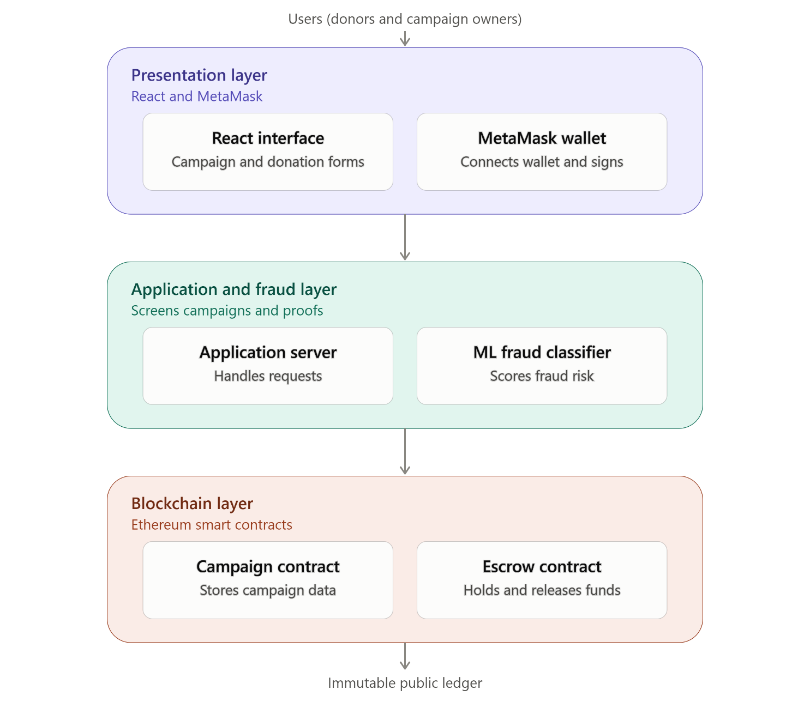

3.2.3 Algorithm
The algorithm below explains the steps, how the system checks campaigns for fraud and how it protects and releases donated money safely.
Algorithm 1: Creating a Campaign and Checking for Fraud
Step 1: The user logs in and the system checks that they are a real, signed-in user.
Step 2: The user fills in the campaign details, such as the medical problem, amount needed, and any hospital documents.
Step 3: The system reads the text and documents the user submitted.
Step 4: The system sends this information to the fraud detection model to check if the campaign looks genuine or suspicious.
Step 5: The fraud detection model gives a score showing how likely the campaign is to be fake.
Step 6: If the score shows the campaign is safe, the system allows it to go live and be saved on the blockchain. If the score shows it is risky, the system blocks it and sends it for manual checking.
Step 7: Once approved, the campaign details are saved as a new block on the blockchain so they cannot be changed later.
Algorithm 2: Receiving Donations Safely
Step 1: A donor logs in and chooses the campaign they want to support.
Step 2: The donor enters the amount they wish to give.
Step 3: Instead of sending the money straight to the campaign owner, the system holds the money in a secure escrow account.
Step 4: The system records the donation (amount, donor, and date) on the blockchain.
Step 5: The donor sees a confirmation and the campaign's updated total.
Algorithm 3: Releasing the Money
Step 1: The campaign owner logs in and requests to withdraw money for a specific need, such as paying a hospital bill.
Step 2: The owner uploads proof, such as a receipt or invoice.
Step 3: The system checks this proof using the fraud detection model to confirm it looks genuine.
Step 4: If the proof passes the check, the system releases the matching amount from escrow to the owner's account. If it fails, the system blocks the withdrawal and flags it for review.
Step 5: The system records the withdrawal on the blockchain and updates the remaining balance for the campaign.
Together, these three simple procedures allow the system to screen out fake campaigns, protect donated funds until they are needed, and only release money when there is proof it is being used for a genuine medical need.
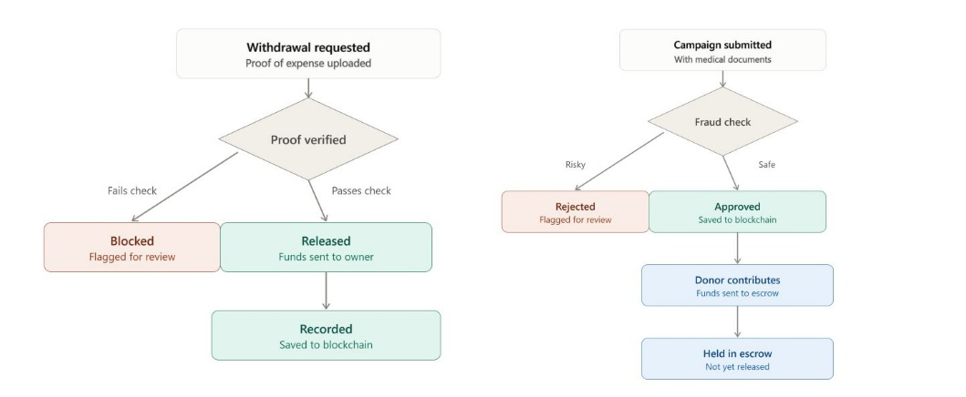

3.2.3 System Flowchart
The system flow begins when a patient registers and submits a medical crowdfunding campaign along with supporting medical documents. The documents are verified by an authorized medical institution, after which the fraud detection module checks for inconsistencies, duplicate claims, and suspicious activities. If verification is successful, a smart contract is deployed and the campaign is published for donations. Donors contribute through their digital wallets, and all transactions are recorded on the blockchain. Once funding conditions are met, the smart contract securely releases the funds and notifies all stakeholders.
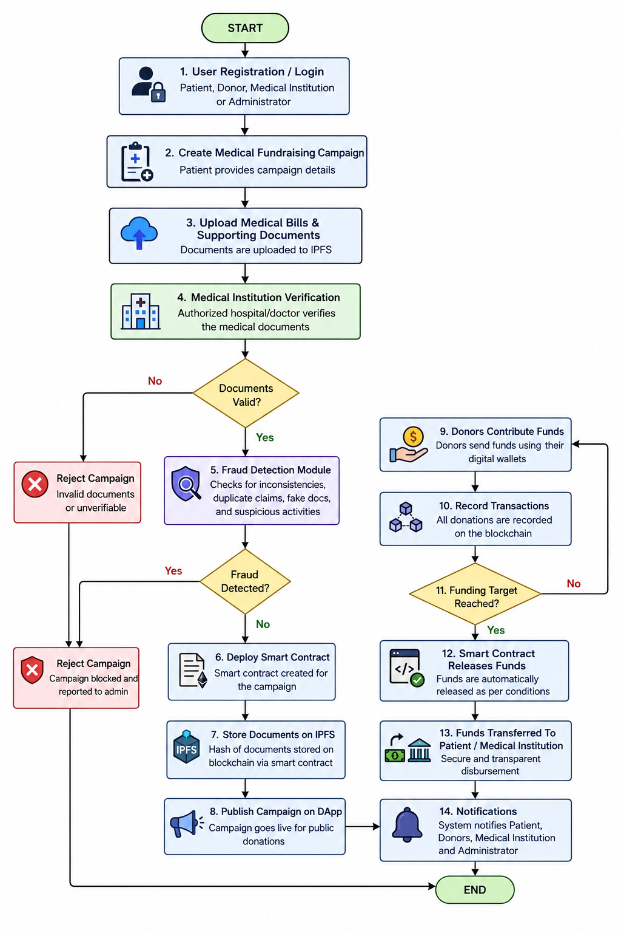
Figure 3.2:. System Flowchart

3.2.4 Current System
At present, individuals seeking to crowdfund medical expenses rely overwhelmingly on centralised platforms such as GoFundMe and comparable services, which function as custodial intermediaries between campaign creators and donors. In the current system, a patient or representative creates a campaign by submitting a narrative description of the medical condition, a requested funding target, and, optionally, supporting documentation such as hospital invoices or physician letters. The platform operator reviews this submission using a combination of automated keyword filters and, in some cases, limited human moderation, before the campaign is published for public fundraising. Donors then contribute funds directly into an account controlled by the platform or the campaign creator, with the platform deducting a processing fee before forwarding the balance. Disbursement of funds to the patient or healthcare provider occurs at the discretion of the campaign creator, with no independent verification that the funds were applied to the stated medical purpose.
This arrangement is presently observable across the major medical crowdfunding platforms operating in both developed and developing economies, and is not a hypothetical construction for this study. Empirical investigations of the medical crowdfunding ecosystem confirm that this custodial, intermediary-controlled model is the dominant operational pattern, with platforms retaining sole authority over fund custody and campaign moderation while donors and auditors are left with no independently verifiable record of fund utilisation.

3.2.5 Challenges in the Current System
The current system suffers from four interrelated challenges that directly necessitate this study. The first is the absence of pre-emptive fraud screening: campaign review at the point of submission typically relies on rudimentary keyword and pattern filters rather than a calibrated predictive model, leaving sophisticated fraudulent narratives largely undetected until after substantial donor harm has already occurred. The second is custodial opacity: because funds pass through and are held by a centralised platform or directly by the campaign creator, neither donors nor independent auditors possess a verifiable, tamper-resistant record confirming that contributions were applied to their stated medical purpose. The third challenge is the lack of conditional, milestone-based disbursement; funds are typically released to the campaign creator in bulk rather than against verified treatment milestones, removing any structural safeguard against diversion of funds to unrelated uses. The fourth challenge, identified directly from the literature reviewed in Chapter Two, is the structural disconnection between fraud detection and fund custody: even where a platform develops or licenses a capable fraud classifier, that classifier's output is advisory only, with no binding mechanism to prevent a flagged campaign from continuing to receive and retain donor contributions. Collectively, these four challenges substantiate the problem statement articulated in Section 1.2 and establish the specific gap that the proposed system is designed to close.

3.2.3 Proposed System
The proposed system is a Transparent Crowdfunding DApp for Medical Bills in which campaign legitimacy screening and fund custody are structurally coupled rather than operated as independent processes. The system is organised into three cooperating layers, illustrated in Figure 3.1: a presentation layer through which patients, donors, and administrators interact with the platform; an application and fraud-detection layer that validates campaign submissions and computes a machine-learning-derived risk classification; and a blockchain layer comprising Ethereum-compatible smart contracts that govern escrow and milestone-based disbursement. Crucially, a campaign is admitted to the blockchain layer, and therefore becomes eligible to receive donor funds, only after it has passed the fraud-detection gate in the application layer; this gating logic is the specific architectural mechanism through which this study closes the gap identified in Section 2.2.3.
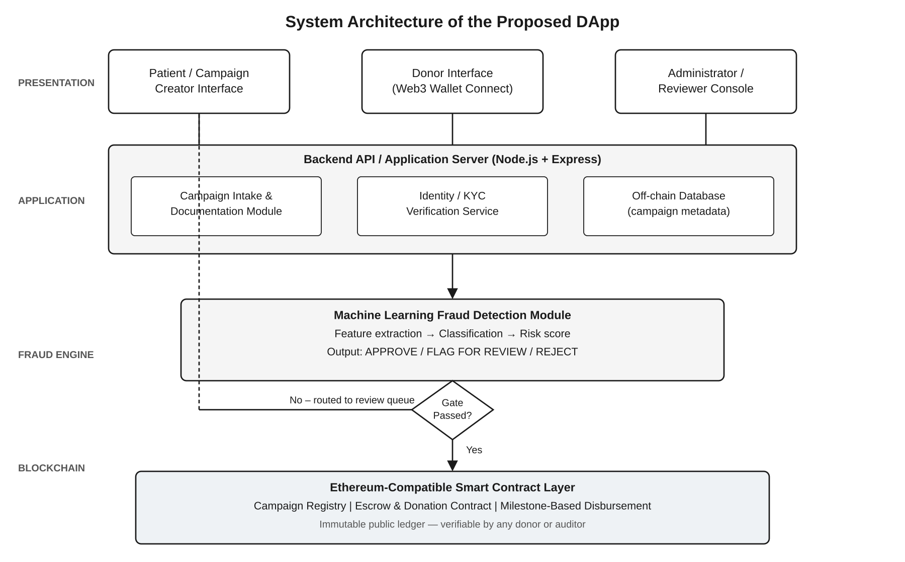
Figure 3.1: Three-Layer System Architecture of the Proposed DApp
The principal actors, or players, who interact with the proposed system are the patient or campaign creator, who initiates and manages a fundraising campaign; the donor, who browses available campaigns and contributes funds; the platform administrator, who reviews campaigns that the fraud-detection module flags for manual inspection; and the machine learning fraud engine itself, which operates as an automated service actor performing classification rather than direct human interaction. The relationships and interactions among these actors and the functions available to each are captured in the use case diagram presented as Figure 3.2.

Figure 3.2: Use Case Diagram of the Proposed DApp
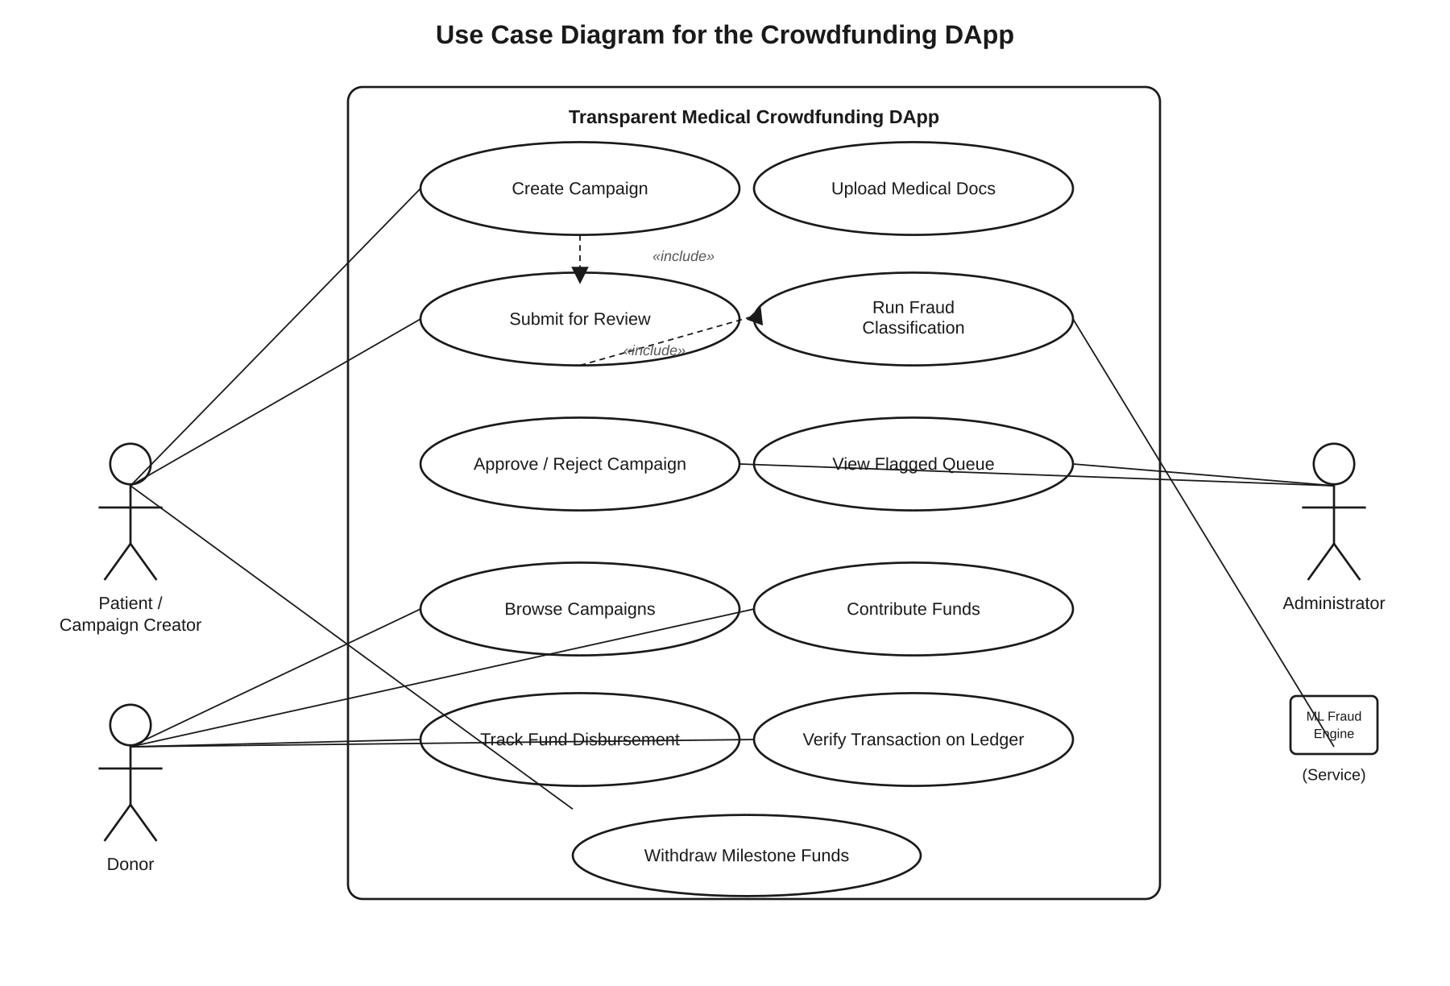In terms of functional requirements, the system must allow a campaign creator to register an account, submit a campaign with supporting documentation, and track the status of that campaign through review, approval, and active fundraising. It must allow the fraud-detection module to extract a defined feature set from each submitted campaign and return a classification of approve, flag for manual review, or reject, consistent with the methodology established in the empirical literature reviewed in Chapter Two. It must allow an administrator to inspect flagged campaigns and render a final approval or rejection decision. It must allow a donor to connect a compatible Web3 wallet, browse approved campaigns, and contribute funds directly into an escrow smart contract. Finally, it must allow any party, donor or otherwise, to independently verify the complete transaction history of a campaign on the public ledger, and must release escrowed funds to the beneficiary only upon satisfaction of pre-defined, contract-encoded milestone conditions.
The non-functional requirements of the system centre on security, transparency, and usability. The smart contract layer must be resistant to common vulnerability classes such as re-entrancy and integer overflow, and must expose all campaign and transaction state through publicly queryable, immutable ledger entries. The fraud-detection module must return a classification result within a response time short enough not to disrupt the campaign-creation workflow, and must be retrainable as new fraud patterns are identified without requiring redeployment of the smart contract layer. The user-facing presentation layer must be accessible to users with limited prior exposure to blockchain or cryptocurrency concepts, abstracting wallet interactions behind a conventional web interface wherever feasible.
The flow of data through the system begins when a campaign creator submits campaign metadata and documentation through the presentation layer; this data is passed to the application layer, where it is persisted in an off-chain database and simultaneously routed to the fraud-detection module for feature extraction and classification. Campaigns that pass the fraud-detection gate are written to the blockchain layer through a campaign-registry smart contract, making them visible to donors; campaigns that are flagged are instead routed to an administrator review queue and are withheld from public listing pending manual adjudication. Once a campaign is live on-chain, donor contributions flow directly into an escrow contract, and disbursement to the beneficiary occurs only when milestone conditions encoded in the disbursement contract are satisfied, at which point the transaction is permanently recorded on the public ledger. This sequence of data movement, decision logic, and conditional disbursement is the operational expression of the architecture depicted in Figure 3.1, and constitutes the instrument through which the empirical data analysed in Chapters Four and Five is generated.

3.3 Methods of Data Collection
The goal of data collection in this study is to assemble the inputs necessary to train, validate, and evaluate the machine learning fraud detection module, and to generate the transactional data required to test the functional correctness of the blockchain layer. Two broad kinds of data are gathered in pursuit of this goal. The first is campaign-level data describing the textual, documentary, and behavioural characteristics of medical crowdfunding appeals, used to train and benchmark the fraud classifier. The second is transactional and operational data generated by exercising the smart contract layer on a controlled testnet, used to evaluate the security, correctness, and gas efficiency of the blockchain component.
Campaign-level data is obtained primarily through secondary collection from publicly accessible crowdfunding platform listings and previously published, ethically cleared research datasets on medical crowdfunding fraud, consistent with the data sources employed in comparable studies reviewed in Chapter Two. Each record in this dataset captures the campaign's textual narrative, requested funding amount, campaign duration, presence and type of supporting documentation, and, where available, an existing fraud annotation. Because confirmed fraud cases constitute a minority of all campaigns, a documented characteristic of this domain consistent with prior empirical findings, the collected dataset is supplemented with synthetically generated adversarial campaign examples designed to mirror the linguistic and structural patterns of confirmed fraud cases, thereby addressing class imbalance without compromising the integrity of the genuine data. This combined dataset is partitioned into training, validation, and test subsets to support supervised learning and unbiased performance evaluation.
Transactional and operational data is generated directly by the researcher through structured exercising of the deployed smart contracts on an Ethereum-compatible test network. This involves simulating campaign creation, donor contributions of varying sizes and frequencies, milestone verification requests, and both successful and adversarial disbursement attempts, including deliberately malformed transactions intended to test the contract's resistance to common exploit patterns. Each simulated transaction is logged with its associated gas cost, execution outcome, and resulting contract state, producing a structured dataset of system behaviour under both normal and edge-case conditions. Taken together, these two data collection procedures directly answer the three guiding questions of this section: the purpose of the research is to evaluate a fraud-gated, blockchain-based medical crowdfunding system; the data gathered comprises annotated campaign records and simulated transaction logs; and the methods and procedures used to gather and process this data are secondary dataset compilation supplemented by synthetic augmentation, and controlled testnet simulation, respectively.

3.3.1 Justification of Methods
The methodological pathway adopted in this study is justified on three grounds. First, the use of secondary, publicly available crowdfunding data, rather than the collection of new primary data directly from patients or donors, is justified by the sensitive and potentially distressing nature of medical fundraising narratives; relying on previously published and appropriately anonymised datasets avoids placing vulnerable individuals at risk of re-identification or further distress, while still providing data with the linguistic and structural richness required to train an effective classifier, an approach consistent with established practice in the empirical literature reviewed in Chapter Two. Second, the use of synthetic adversarial augmentation to address class imbalance is justified by the well-documented scarcity of confirmed fraud labels in crowdfunding datasets; without such augmentation, a classifier trained on the naturally occurring class distribution would be biased toward predicting the majority legitimate class, undermining the very capability the system is designed to provide. Third, the use of a controlled testnet, rather than mainnet deployment with real cryptocurrency, for evaluating the blockchain layer is justified by the scope boundaries established in Section 1.5; a testnet environment permits rigorous, repeatable functional and adversarial testing of the smart contract logic without exposing the research to financial risk or requiring regulatory clearance that lies outside the scope of an academic project. Together, these methodological choices ensure that the data collected is appropriate to the research questions posed, ethically sound, and reproducible by future researchers seeking to extend this work.

REFERENCES
Blockchain Trust Management for Crowdfunding
A decentralized trust management mechanism for crowdfunding. (2023). Information Sciences, 638, 118969.
Charity Transparency Using Blockchain
Islam, A., et al. (2020). A framework to make charity collection transparent and auditable using blockchain technology. Computers & Electrical Engineering, 83, 106588.
Blockchain-based Medical Crowdfunding
Raphael, R., & Jaison, J. K. (2025). Medical crowdfunding with blockchain and machine learning: A secure and intelligent framework. International Journal for Research in Applied Science and Engineering Technology.
Blockchain Anti-Fraud Framework
Zhang, R., Xue, R., & Liu, L. (2020). Combating health care fraud and abuse: Conceptualization and prototyping study of a blockchain antifraud framework. Journal of Medical Internet Research, 22(9).
Healthcare Insurance Fraud Detection
Ismail, L., & Zeadally, S. (2021). Healthcare insurance frauds: Taxonomy and blockchain-based detection framework (Block-HI). IT Professional, 23(4), 36–43.
Hybrid Blockchain and AI for Fraud PreventionB. S., L., & Rekha, K. S. (2025). A hybrid blockchain–AI architecture for secure and transparent decentralized crowdfunding. Journal of Artificial Intelligence and Technology, 5, 557–562.
Blockchain Crowdfunding DApp
Shinde, A., Penshanwar, P., Bhandari, N., Arya, S. N., & Sahil. (2024). Blockchain-driven collective funding DApp. International Journal for Research in Applied Science and Engineering Technology.

